Contents
Incognito browsing 1
Clearing browser history 2
Google Chrome 2
Mozilla Firefox 3
Microsoft Edge 4
Microsoft Internet Explorer 5
Disabling extensions 7
Google Chrome 7
Mozilla Firefox 8
Microsoft Edge 9
Microsoft Internet Explorer 10

 | In April 2021, we discovered that some users were unable to run reports on the HR Reporting servers unless they took the steps outlined below – see OSM Problem Record #40002259 for full details.  These steps may prove useful for other browser-related issues.

If a user is experiencing problems with a browser-based process, e.g. running reports or doing work in the Portal, there are some common troubleshooting techniques you can employ to try to resolve the issue. This document explains how to: run an incognito browsing session, clear browsing history, and disable extensions on all common PC browsers.

Incognito browsing

If a user is having problems with a process and you suspect their browser may be to blame, it is useful to try running the process in an “incognito” browser session before you clear their history or disable their extensions.

An incognito session is a temporary browser session that is isolated from the browser's main session and user data – that is, it is “unaware of” any of the cached data or extensions that are normally present when the browser is running.

To open an incognito browser session in any browser, follow the instructions below.

Browser | Directions
Google Chrome | Keyboard shortcut: Ctrl + Shift + N  From the menu: Select “New incognito window”
Mozilla Firefox | Keyboard shortcut: Ctrl + Shift + P  From the menu: Select “New Private Window”
Microsoft Edge | Keyboard shortcut: Ctrl + Shift + N  From the menu: Select “New InPrivate window”
Microsoft Internet Explorer | Keyboard shortcut: Ctrl + Shift + P  From the menu: Select “Safety” and then “InPrivate browsing”

The browser session may open in a new tab or a new window, depending on the browser you are using.

If your user is able to run their process successfully in an incognito browsing session, that indicates that you will need to clear their browser history and disable their extensions to allow the user to run their process in a normal browser session. Information on how to clear history and disable extensions in each browser is presented below.

Clearing browser history

Google Chrome
Search bar link: chrome://settings/clearBrowserData
Keyboard shortcut: Ctrl + Shift + Delete
From the menu: Select “More tools” and “Clear browsing data”:

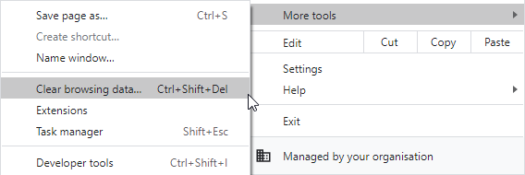

Any of these methods will take you to the chrome://settings/clearBrowserData screen, where a floating window labelled “Clear browsing data” appears. Go to the Advanced tab of this window and select all items:

- Browsing history
- Download history
- Cookies and other site data
- Cached images and files
- Passwords and other sign-in data
- Auto-fill form data
- Site settings
- Hosted app data

Set the Time range to “All time” and click Clear data:

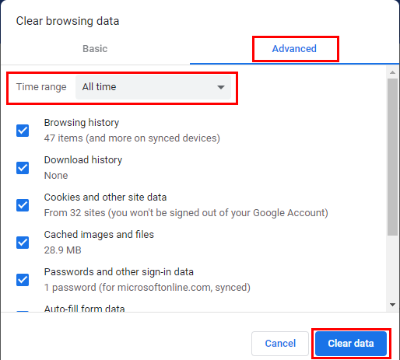

The screen will refresh itself briefly and the “Clear browsing data” window will disappear once the data has been cleared.

Mozilla Firefox

Keyboard shortcut: Ctrl + Shift + Delete

 | The keyboard shortcut is the fastest way to manage browser history in Firefox, although distinct types of browser history (e.g. cookies or auto-fill form data) can be managed individually by going to the search bar link: about:preferences#privacy

After entering Ctrl + Shift + Delete, the “Clear All History” window will pop up. Select all items in the History and Data sections:

- Browsing & Download History
- Active Logins
- Form & Search History
- Cookies
- Cache
- Site Preferences
- Offline Website Data

Set the Time range to clear to “Everything” and click OK:

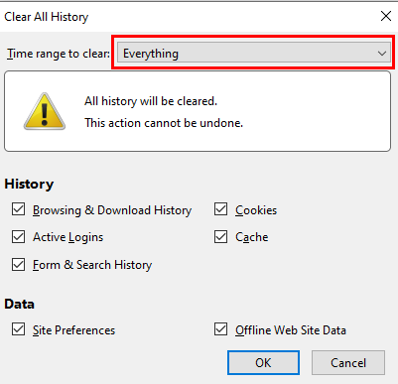

The screen will refresh itself briefly and the “Clear All History” window will disappear once the data has been cleared.

Microsoft Edge

Search bar link: edge://settings/clearBrowserData
Keyboard shortcut: Ctrl + Shift + Delete
From the menu: Select “Settings” to be taken to the Settings page. Click on “Privacy, search, and services” in the left-hand menu bar:

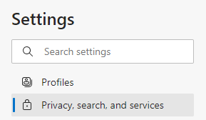

Scroll to the section titled “Clear browsing data” and click the button labelled “Choose what to clear”:

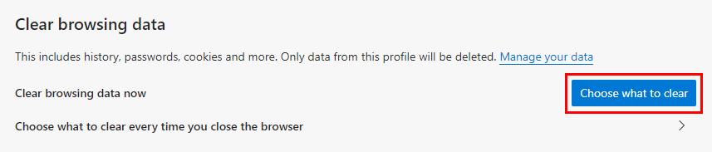

Any of these methods will take you to the edge://settings/clearBrowserData screen, where a floating window labelled “Clear browsing data” appears. Select all items:

- Browsing history
- Download history
- Cookies and other site data
- Cached images and files
- Passwords
- Autofill form data (includes forms and cards)
- Site permissions
- All data from the previous version of Microsoft Edge

Set the Time range to “All time” and click “Clear now”.

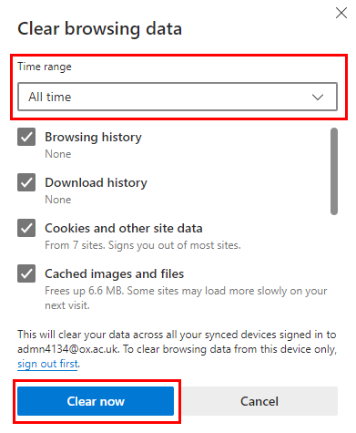

The screen will refresh itself briefly and the “Clear browsing data” window will disappear once the data has been cleared.

Microsoft Internet Explorer

Search bar link: n/a for Explorer
Keyboard shortcut: Ctrl + Shift + Delete
From the menu: Select “Safety” and “Delete browsing history”:

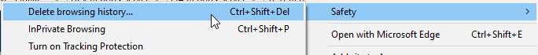

Either of these methods will open a pop-up window labelled “Delete Browsing History”. Deselect the first item:

- Preserve Favourites website data

Now select all the remaining items:

- Temporary Internet files and website files
- Cookies and website data
- History
- Download History
- Form data
- Passwords
- Tracking Protection, ActiveX Filtering, and Do Not Track

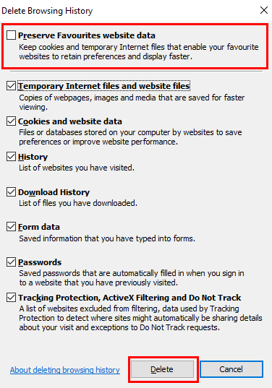

Click “Delete”. The screen will refresh itself briefly and the “Delete Browsing History” window will disappear once the data has been cleared.

Disabling extensions

 | NB: It is only necessary to disable all extensions if you are unsure which extension is causing the problem. You can isolate the problematic extension by re-enabling extensions one-by-one and testing your process (e.g. running a report).  - If you are able to run your process successfully, the re-enabled extension can remain enabled.  - Once you have isolated the problematic extension, you can either leave it permanently disabled, or advise the user to perform their process in another browser which does not have this extension attached.

Google Chrome

Search bar link: chrome://extensions/
From the menu: Select “More tools” and “Extensions”:

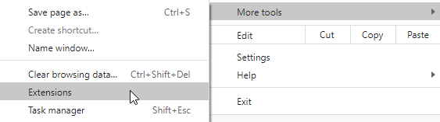

The Extensions page will open, and any browser extensions which have been installed for a user’s Google Chrome browser will be displayed. You can see from the toggle on each extension icon whether an extension is enabled or disabled.

Enabled (blue toggle):

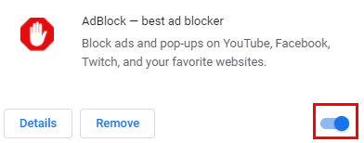

Disabled (grey toggle):

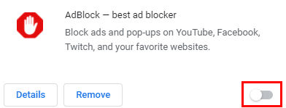

Simply toggle an enabled extension to disable it. Changes are automatically saved.

Mozilla Firefox

Search bar link: about:addons
Keyboard shortcut: Ctrl + Shift + A
From the menu: Select “Add-ons and Themes”:

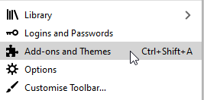

The Add-ons Manager screen will open. Select “Extensions” from the left-hand menu bar:

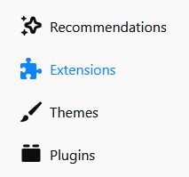

A list of the extensions installed on Firefox will be displayed. Just like in Chrome, you can see from the toggle on each extension icon whether an extension is enabled or disabled.

Enabled (blue toggle):

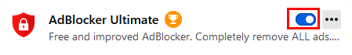

Disabled (grey toggle):

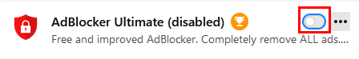

Unlike Chrome, Firefox will also explicitly flag disabled extensions with the phrase “(disabled)”, and will put them on a separate list within the Add-ons Manager:

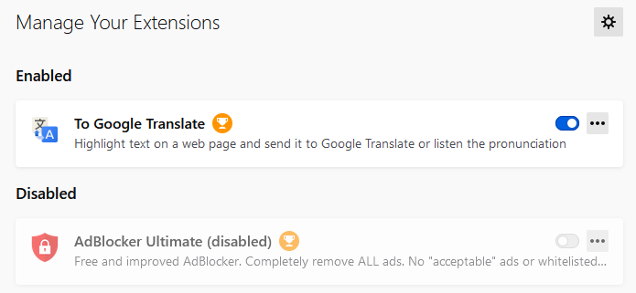

Toggle an enabled extension to disable it. Changes are saved automatically.

Microsoft Edge

Search bar link: edge://extensions/
From the menu: Select “Extensions”:

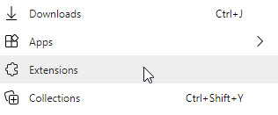

The Extensions screen will open. A list of the extensions installed on Edge will be displayed. Once again, you can see from the toggle on each extension icon whether an extension is enabled or disabled.

Enabled (blue toggle):

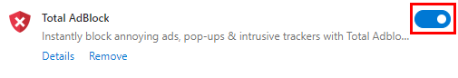

Disabled (grey toggle):

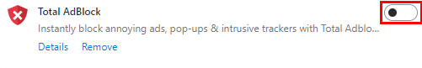

Toggle an enabled extension to disable it. Changes are saved automatically.

Microsoft Internet Explorer

From the menu: Select “Manage add-ons”:

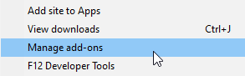

The “Manage Add-ons” window will pop up. In the left-hand menu bar, select “Toolbars and Extensions”:

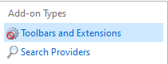

Internet Explorer is an older browser so its user-interface is less friendly than the other browsers shown so far. You will need to check the Status column for each extension to see whether or not it is enabled:

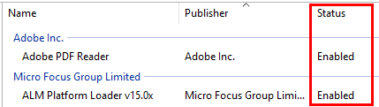

To disable an extension, you can right-click on it and select “Disable” from the pop-up menu:

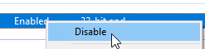

Alternatively, you can click the “Disable” button at the bottom of the “Manage Add-ons” window:

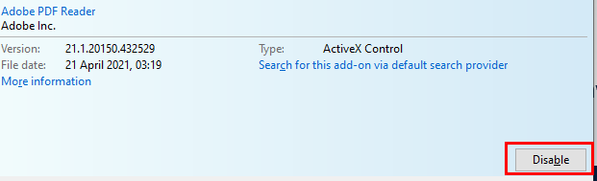

The status column will update with the new “Disabled” status:

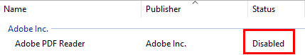

Changes are saved automatically, so simply click “Close” when you’re finished.

